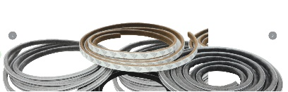
HOME PAGE – SCROLING IMAGE IS GETTING CUT

The success history of Precision Weather Strip in 10 years ( 13 Year)
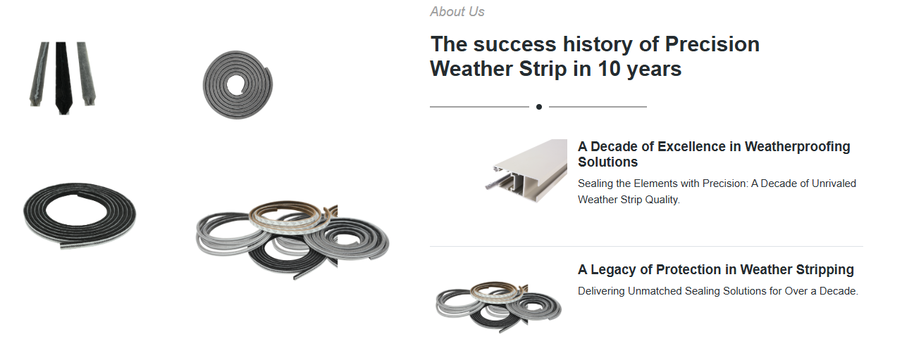
Remove 4 arrow left side image and right side 2 images
Add Below images Add below images
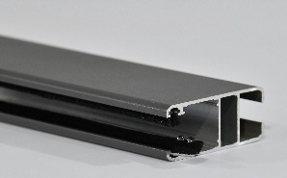
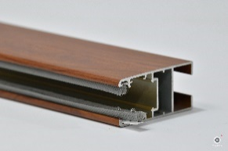

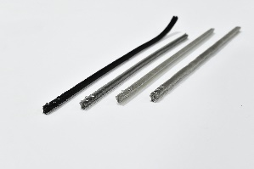
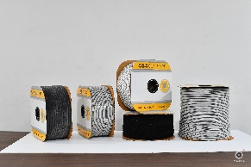

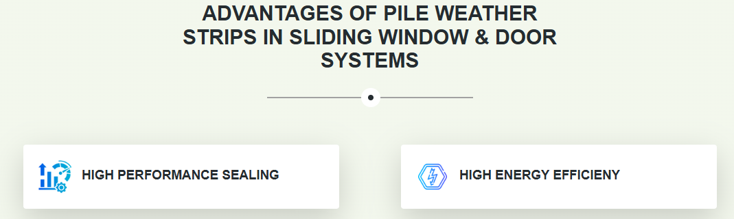

SPELLING IS WRONG (EFFICIENCY)

ADD ABOVE BOX PROTECTION AGAINST WITH ICON

PRODUCT

ALL THE TEXT COLOR IN ENTIRE WEBSITE AND TABLE COLOR CHANGE TO BLACK

A PART FROM TOP HEADER Home , about product, contact let it be the same only

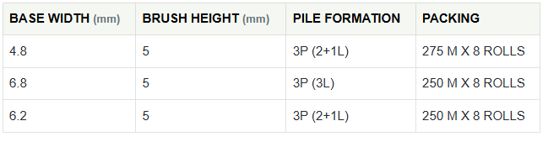

ALL BOX CELL SHOULD BE SAME SIZE IN ALL THE BOX INSIDE THE PRODUCT LIKE ABOVE.
CHANGE THE LIGHT COLOR TO BLACK

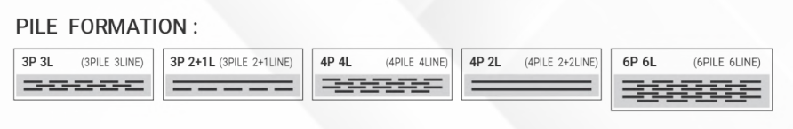
ADD IN ALL THE PRODUCT BELOW END PAGE
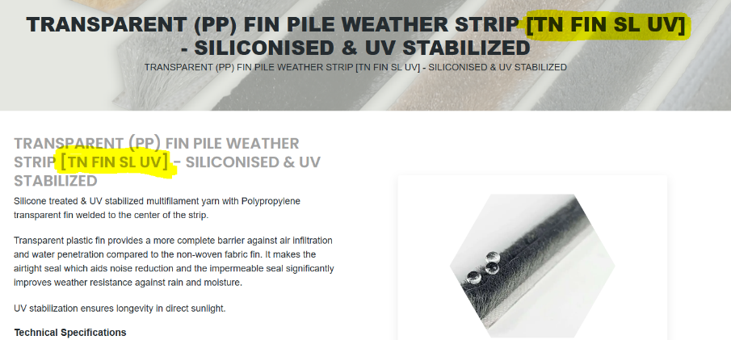

PILE IMAGE IS GETTING CUT UNZOOM IT

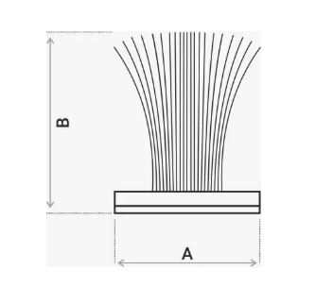
DIAGRAM IMAGE GETTING LIGHT GRAY PATCH in the baground USE PNG ONLY
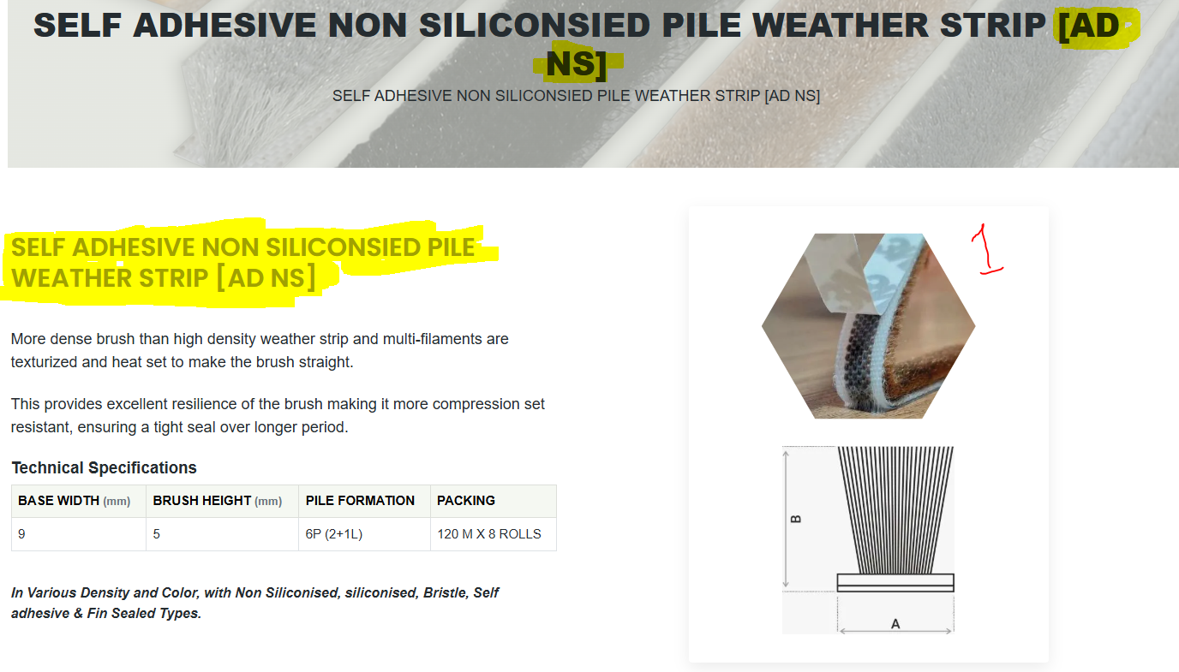

Change the 1st pile image inside the product of AD NS
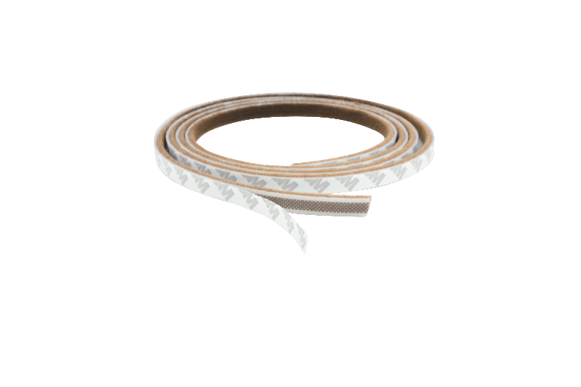

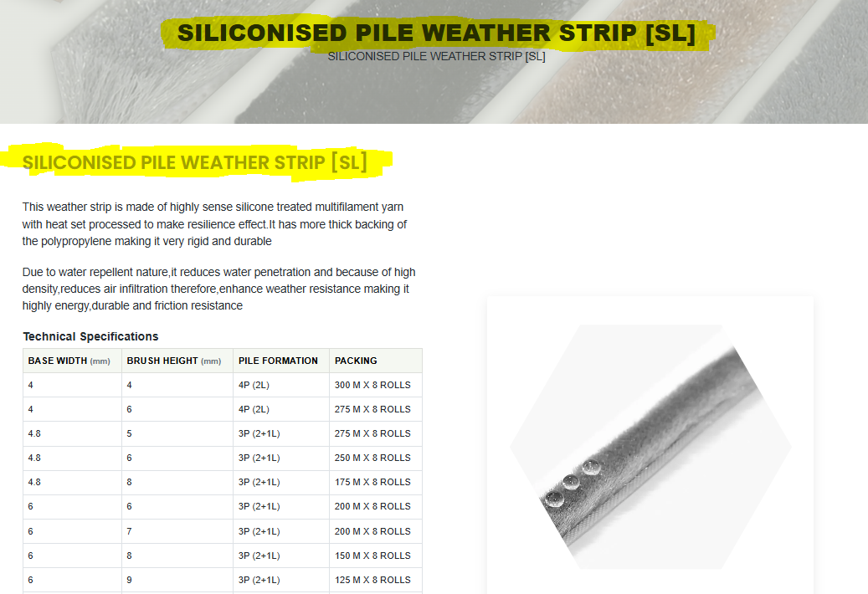

Pile image is getting cut correct it and add below image also
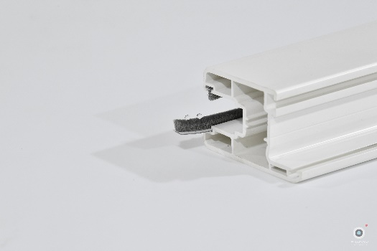

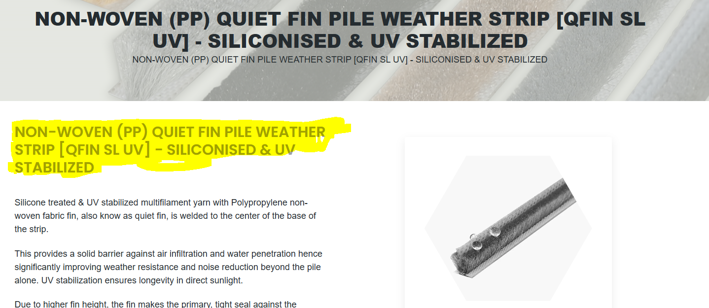
Remove the pile image from inside and add below
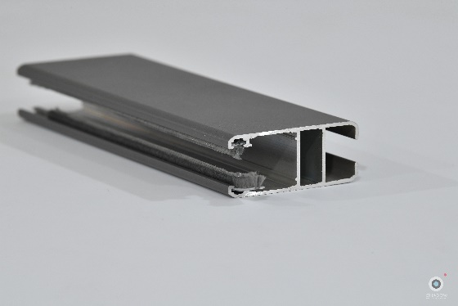

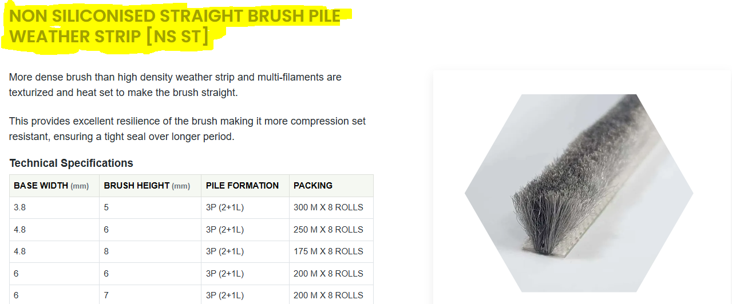
Pile image is ok add below image also

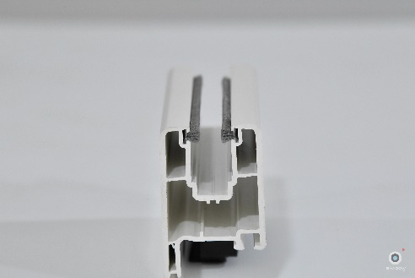
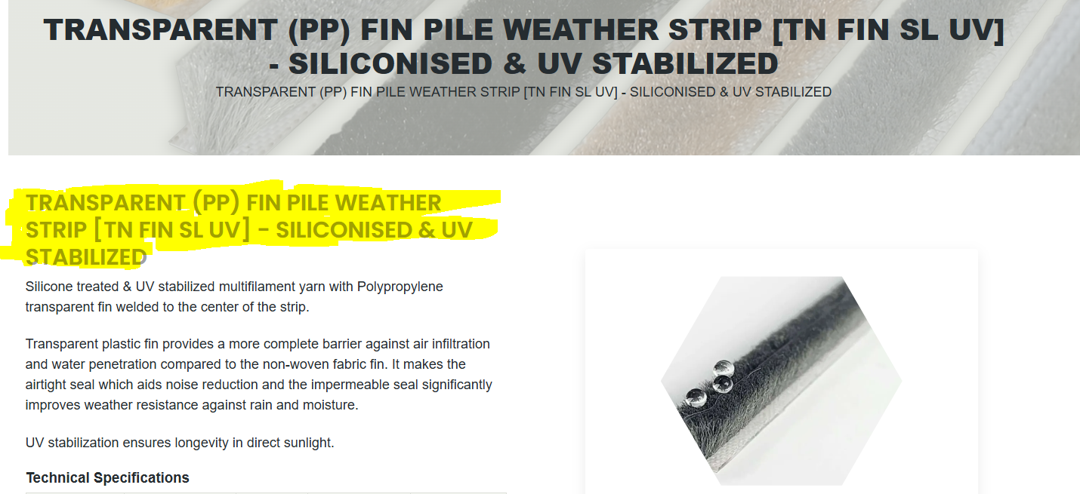
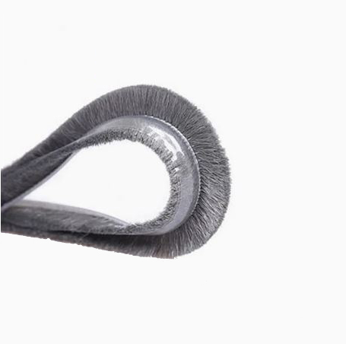
Remove the pile image from inside and add below two image
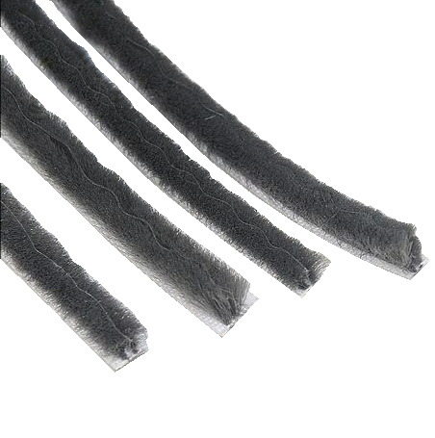

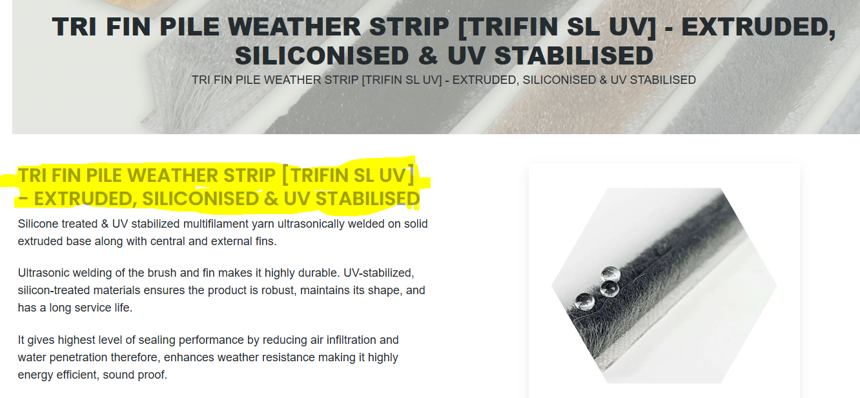
Remove the pile image and add below images 2
